Mathematical Theory

🌟 Definition
# Source: AI Source: Provided by: [Data Path: Persons Table -> ID Column: 1, Name_En Column: Motasem Essam] -> From: [ChatGPT] on [5/29/2026]
A mathematical theory is a structured system of mathematical knowledge built from definitions, axioms, theorems, and proofs that explains and studies a particular set of mathematical objects and relationships.
A mathematical theory is broader than a single theorem. It is an organized collection of concepts and proven results within a specific area of mathematics.

🏗 Building Blocks of a Mathematical Theory
# Source: AI Source: Provided by: [Data Path: Persons Table -> ID Column: 1, Name_En Column: Motasem Essam] -> From: [ChatGPT] on [5/29/2026]
A mathematical theory typically consists of:
1. Mathematical Language
The symbols, notation, and terminology used to express ideas.
2. Mathematical Objects
The entities being studied.
Examples:
- Numbers
- Sets
- Functions
- Vectors
- Graphs
3. Definitions
Precise meanings of terms and concepts.
4. Axioms
Basic assumptions accepted without proof.
5. Theorems
Statements proven from axioms, definitions, and logic.
6. Proofs
Logical arguments that establish the truth of theorems.

🎯 Purpose of a Mathematical Theory
# Source: AI Source: Provided by: [Data Path: Persons Table -> ID Column: 1, Name_En Column: Motasem Essam] -> From: [ChatGPT] on [5/29/2026]
- Organize mathematical knowledge
- Explain relationships among mathematical objects
- Provide a framework for proving new results
- Solve classes of mathematical problems
- Develop deeper understanding of mathematical structures

🧩 Examples of Mathematical Theories

Set Theory
# Source: AI Source: Provided by: [Data Path: Persons Table -> ID Column: 1, Name_En Column: Motasem Essam] -> From: [ChatGPT] on [5/29/2026]
Studies sets and their relationships.
Objects: Sets
Axioms: Axioms of set theory
Theorems: Cantor's Theorem and many others

Number Theory
# Source: AI Source: Provided by: [Data Path: Persons Table -> ID Column: 1, Name_En Column: Motasem Essam] -> From: [ChatGPT] on [5/29/2026]
Studies properties of integers.
Objects: Natural numbers and integers
Theorems: Fundamental Theorem of Arithmetic, Euclid's Theorem

Group Theory
# Source: AI Source: Provided by: [Data Path: Persons Table -> ID Column: 1, Name_En Column: Motasem Essam] -> From: [ChatGPT] on [5/29/2026]
Studies algebraic structures called groups.
Objects: Groups
Theorems: Lagrange's Theorem and others

Graph Theory
# Source: AI Source: Provided by: [Data Path: Persons Table -> ID Column: 1, Name_En Column: Motasem Essam] -> From: [ChatGPT] on [5/29/2026]
Studies networks of vertices and edges.
Objects: Graphs
Theorems: Euler's Theorem and many graph-related results

Euclidean Geometry
# Source: AI Source: Provided by: [Data Path: Persons Table -> ID Column: 1, Name_En Column: Motasem Essam] -> From: [ChatGPT] on [5/29/2026]
Studies points, lines, and geometric figures in Euclidean space.
Objects: Points, lines, triangles, circles
Axioms: Euclid's Postulates
Theorems: Pythagorean Theorem

🔗 Relationship to Other Mathematical Concepts
# Source: AI Source: Provided by: [Data Path: Persons Table -> ID Column: 1, Name_En Column: Motasem Essam] -> From: [ChatGPT] on [5/29/2026]
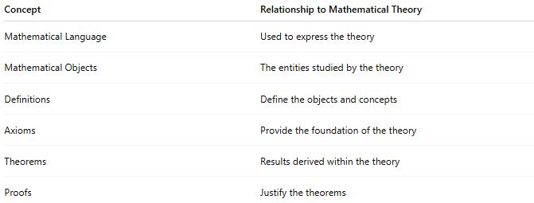
Concept | Relationship to Mathematical Theory
Mathematical Language | Used to express the theory
Mathematical Objects | The entities studied by the theory
Definitions | Define the objects and concepts
Axioms | Provide the foundation of the theory
Theorems | Results derived within the theory
Proofs | Justify the theorems

📊 Hierarchy of Mathematical Knowledge
# Source: AI Source: Provided by: [Data Path: Persons Table -> ID Column: 1, Name_En Column: Motasem Essam] -> From: [ChatGPT] on [5/29/2026]
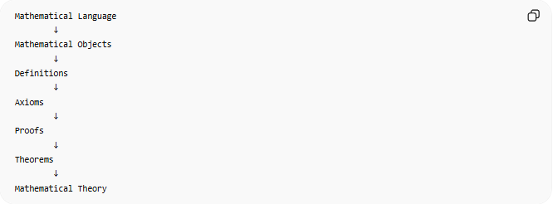
Mathematical Language
↓
Mathematical Objects
↓
Definitions
↓
Axioms
↓
Proofs
↓
Theorems
↓
Mathematical Theory
A mathematical theory is the organized system that emerges from all of these components working together.

✏️ Example
# Source: AI Source: Provided by: [Data Path: Persons Table -> ID Column: 1, Name_En Column: Motasem Essam] -> From: [ChatGPT] on [5/29/2026]
Euclidean Geometry
Objects: Points and lines
Definition: Triangle
Axiom: Through any two distinct points there is exactly one line.
Theorem: The angles of a triangle sum to 180°.
Together, these form part of the mathematical theory of Euclidean geometry.

🧭 Summary
# Source: AI Source: Provided by: [Data Path: Persons Table -> ID Column: 1, Name_En Column: Motasem Essam] -> From: [ChatGPT] on [5/29/2026]
A mathematical theory is a coherent body of mathematical knowledge built from mathematical objects, definitions, axioms, proofs, and theorems. It provides a framework for understanding a particular area of mathematics and for discovering new mathematical truths.

